**DAILY ONLINE ACTIVITIES SUMMARY**

|  |  |  |  |  |  |  |  |  |
| --- | --- | --- | --- | --- | --- | --- | --- | --- |
| **Date:** | **07/06/2020** | | | | | **Name:** | **Spoorthy Balaji** | |
| **Sem & Sec** | **6th & B** | | | | | **USN:** | **4al17cs098** | |
| **Online Test Summary** | | | | | | | | |
| **Subject** | | **SSCD** | | | | | | |
| **Max. Marks** | | **30** | | **Score** | | | **26** | |
| **Certification Course Summary** | | | | | | | | |
| **Course** | **Introduction to Information Security** | | | | | | | |
| **Certificate Provider** | | | **Great Learning Academy** | | **Duration** | | | **6hours** |
| **Coding Challenges** | | | | | | | | |
| **Problem Statement:3** Programs | | | | | | | | |
| **Status: Solved** | | | | | | | | |
| **Uploaded the report in Github** | | | | | **yes** | | | |
| **If yes Repository name** | | | | | <https://github.com/spoorthybalaji/Daily_Status> | | | |
| **Uploaded the report in slack** | | | | | **yes** | | | |

IA TEST

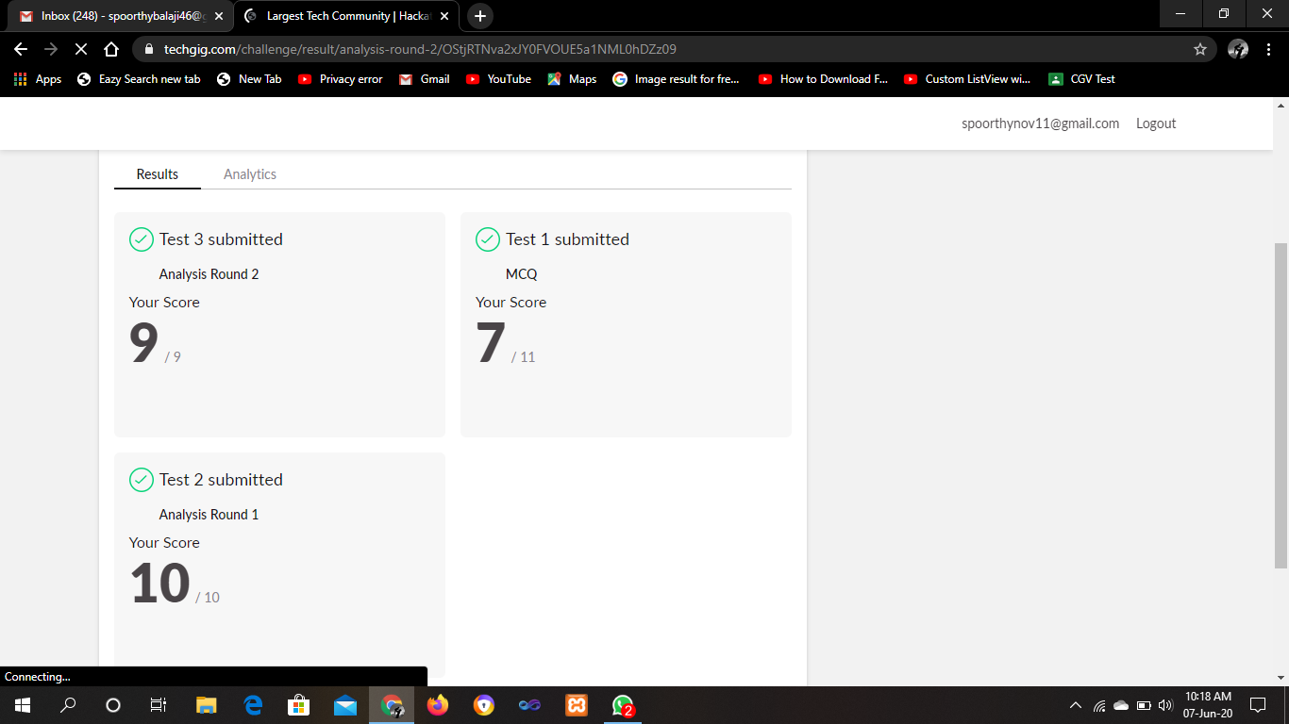

CERTIFICATION COURSE

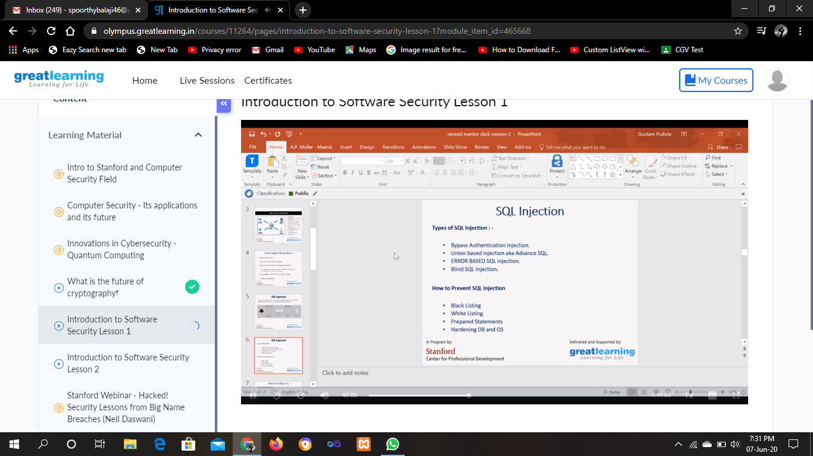

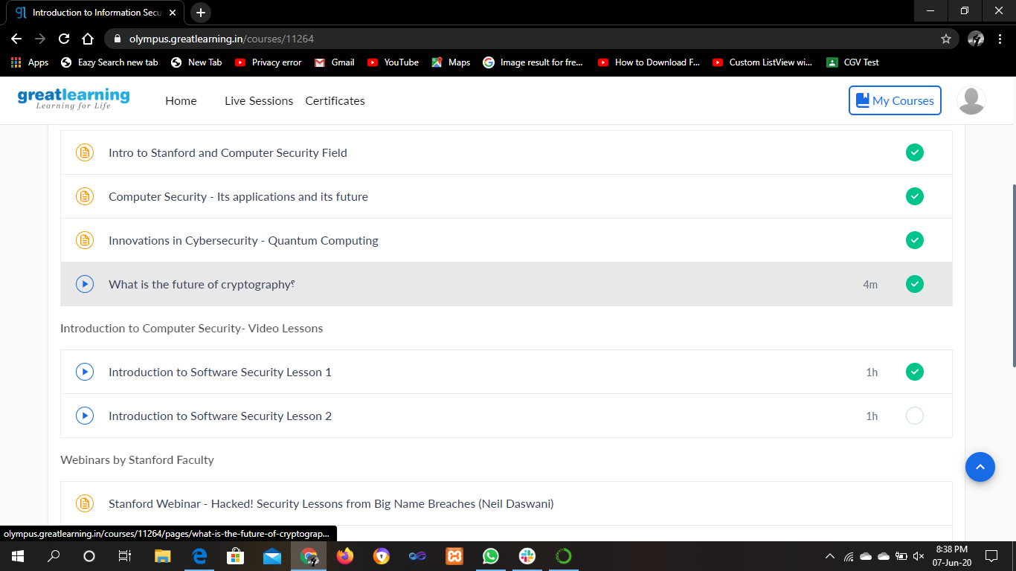

ONLINE CODING

Java program:write a java Program to print smallest and biggest possible palindrome word in a given string

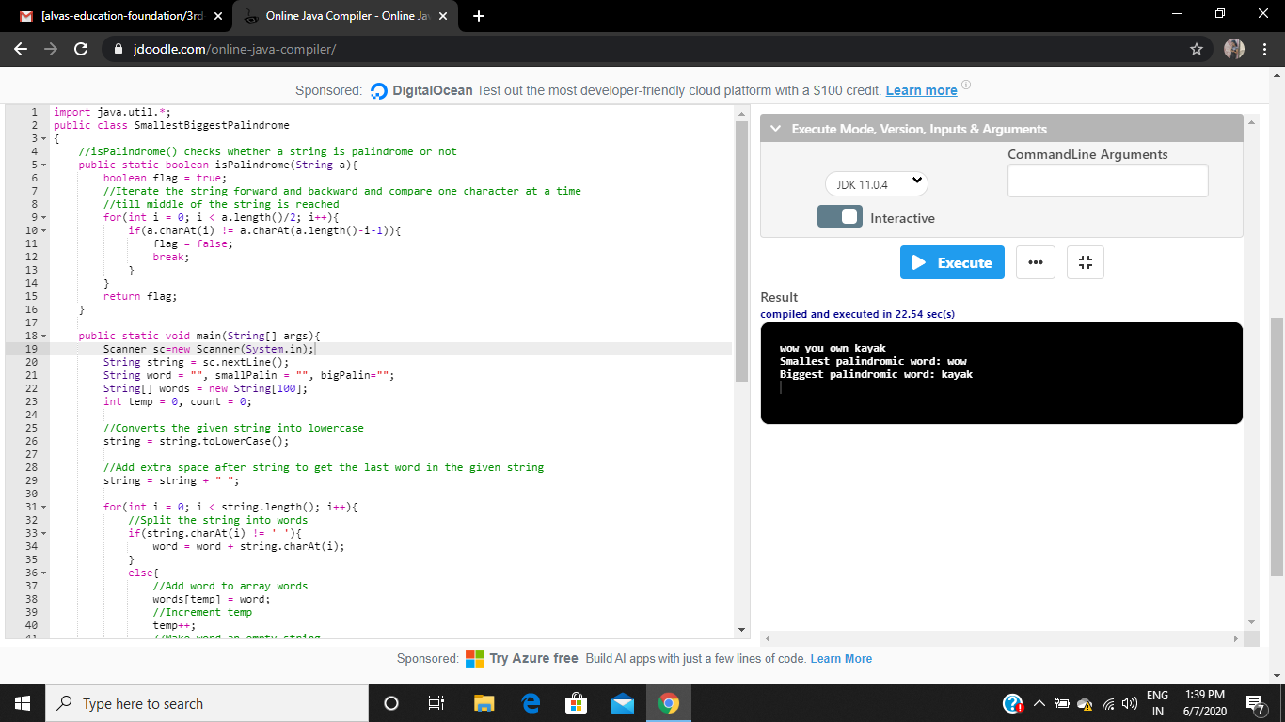

Python program 1:Print a list of first and last 5 elements where the values are square of numbers between 1 and 30 (both included)

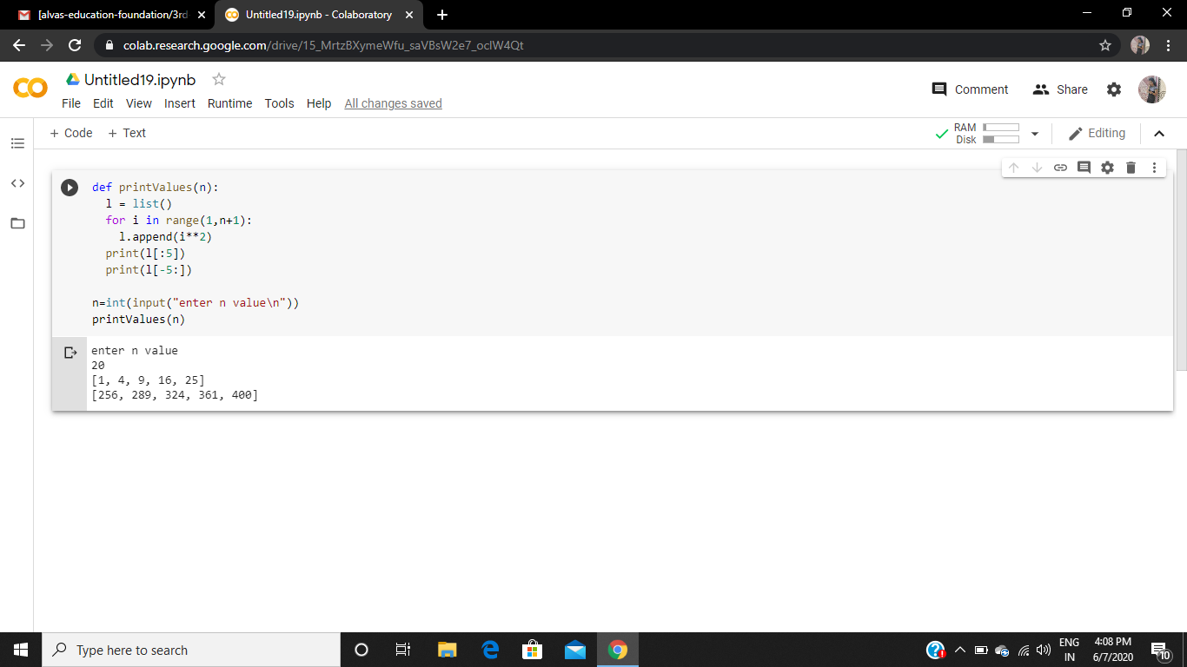

Python program 2: Python Program to Copy the Contents of One File into Another.

